MR2 OWNERS CLUB OF AUSTRALIA - QUEENSLAND CHAPTER INC

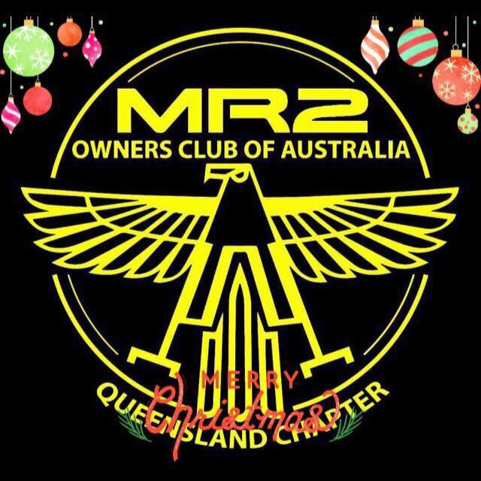
ANNUAL GENERAL MEETING December 12th 2021

AGENDA

- OPEN MEETING TIME
- ATTENDEES CONFIRMED AND APOLOGIES READ AND NOTED
- MINUTES OF PREVIOUS AGM AND COMMITTEE MEETINGS READ AND CONFIRMED
- PRESIDENTS REPORT
- TREASURERES REPORT – FINANCIAL STATEMENT
- SECRETARYS REPORT
- PRESENTATION OF AWARDS
- ELECTION OF COMMITTEE MEMBERS
- PROPOSED ACTIVITIES 2022
- GENERAL BUSINESS
- MEETING CLOSED

ANNUAL GENERAL MEETING December 6th 2020

- OPEN MEETING TIME -

- ATTENDEES CONFIRMED AND APOLOGIES NOTED

APOLOGIES: 19
PETER DECANTO, JOHAN RESENBRINK, ERIC MANDERSON, JAMIE LINEY, MANCHY LAM, CINDY LAUS,
ROSS DYMOND, BRANDON SPEED, CHRIS SOLOMAN, SHAUGHAN LUXTON, JOSH MITCHELL,
WILL AHLSTRAND, GRANT CLEMENTS, MATT WOLASTON, STEPHEN WILLIAMS, TIM ZEMICK
BRADY GRINDROD, TIAH JONES, JACK MANDERSON,
ATTENDEE: 21
DANNY RAJAMAE, BEN PINKSTONE, TONY COUGAR, DAVE AND KIM BUSMER, DOM AND MEL KOLSTIG
RYAN MONTGOMERY, MATT ARCADIO, JOEL KAMHOLTZ, BARRY CREW, BEN AND MARY SCHNEIDER
NIKI AND JAKE LOMBARDI, ETHAN MCARTHUR, BARRY TURNER, JOHNY AND KAREN WUTRICH
ZAK AND KELLY BOYD

- MINUTES OF PREVIOUS AGM AND COMMITTEE MEETINGS READ AND CONFIRMED
MINUTES OF PREVIOUS AGM MEETING ADOPTED
MOTION MOVED BY
SECONDED BY

- PRESIDENTS REPORT – Ben Pinkstone

Since the last AGM work and home commitments have vastly reduced my time to be able to attend and organise runs this year.
It has been a very uncertain year with many political shots from the hip on restrictions while dealing with Covid and its many iterations and issues.
A mildly succefful year has been due to three valued members of the club working together and taking the lead on most of the events in my absence. I’d like to acknowledge Danny Rajamae and his up beat efforts to get events off the ground. I’d like to acknowledge Johnny Wutrrich and his shear determination while under significant personal pressure and demands to still host an event at his house and thank you to his wife Karen who supports him. I’d like to acknowledge Dominic Kolsteg who provides support to both danny and Johnny with the big and small tasks of running the club.

We have had our club attend the start of the year with a car park meet at the Colmslie
We have had our club be welcomed into their business SD Automotive by Ross Dymond with a tech day and BBQ held on site for all members. I’d like to acknowledge Ross’s enthusiasm for the MR2 Marque and thank him for his support to our members with their vehicles.

In the middle part of the year because of further covid restrictions events were sparse and a change in value of these great vehicles also has seen them update from a cheap runabout to potentially an investment for some.

Time spent on the track has waned with more focus on restoring the MR2 and keeping the MR2 in great condition. Many upgrades and engine conversions are afoot with many members also having strained work commitments while COVID conditions still hamper organising major meets.

- TREASURERES REPORT – FINANCIAL STATEMENT – Ryan Montgomery

The club is being run to the standards required and the treasurer reports that the club is in good standings now and for in the future. The account is conducted in a very reasonable and responsible manner and it holds the club in good stead in what ever events it will choose to enter in 2022.

- SECRETARYS REPORT – Ben Schneider

The club continues to be incorporated and the motorsport Australia affiliation for the clubs protection has been renewed for the year and an updated mailing address has been completed.

- PRESENTATION OF AWARDS
The president acknowledged the efforts the VICE PRESIDENT – DANNY RAJAMAE
The president acknowledged the efforts the SECRETARY – BEN SCHNEIDER
The president Acknowledged the efforts of the Treasurer – RYAN MONTGOMERY
The president acknowledged the efforts of the run manager – ZAK BOYD

The tough and arguably most coveted award that is given within the club is the Presidents Award. The president by his own admission had a hard time deciding who was the most worthy of the admiration of the club and the award. There was great poise with who should be selected for this award and it came down to the wire on the decision. After all the checks and tallies of outstanding representation to the club the final honourable award went to JOHNNY WUTTRICH.
Past Presidents Award recipients:
2016-Roger Hayter, 2017-Amy Bebbington, 2018-Wil Ahlstrand, 2019-Ben Schneider, 2020-Johnny Wuttrich.

- NOMINATION AND ELECTION OF COMMITTEE MEMBERS FOR 2021.
  - Nomination for President -
    - Nom by seconded by

  - Nomination for Vice President -
    - Nom , seconded by

  - Nomination for Treasurer -
    - Nom by, seconded by

  - Nomination for Secretary -
    - Nominated, seconded by

  - Nomination for run manager – Zak Boyd
    - Nominated by , seconded by

All positions accepted and filled

- PROPOSED ACTIVITIES 2022
In 2021 - Discussion held around attendance of the club runs and how much time it takes to organise them by the committee. It was proposed by the president that we only do 4 Run events per year instead of having 8 runs. These could incorporate the ICC and club track days by lining up the times to allow better use of the meet/run.

North - The Saturday Night run up mt mee from Nerangba Pizza.?
West - Tour de force of the mountains going to pitstop café and on to other parts of the range

Tech day – SD automotive
Bunya Mountains – Covid permitting.
Track day – off the back of the ICC track days at Morgan Park Sprints or combined with ICC / track day
Nationals – ???? – Hunter Valley NSW, travel to the MR2 Track day at Wakefield Park in August.
Icc calender – match up the ICC calender with the club calendar in the new year
AGM to be held again at the Christmas Party where more can attend rather than in the colder June.

- GENERAL BUSINESS
Social activities – weekend events preferred by those attending
Stickers / club shirts / club hats / club keychains review to be ordered or looked at for short restock.

- Meeting closed

