OFFICIAL ENTRY FORM
for the MR2 Nationals 2024 to be held in
Wodonga, Victoria from Friday 4 October to Monday 7 October 2024.
By completing and signing this form you agree to abide by the conditions of entry set out on Page 2.
PLEASE READ THEM CAREFULLY

Please complete ALL the following information, sign and date BOTH pages and
return BOTH PAGES completed, together with proof of payment, to the Nationals Team by email: nationals@mr2club.com.au
ENTRIES CLOSE SUNDAY 11 AUGUST 2024 for planning purposes & shirt orders

Name of Driver
Name of Passenger
Address
 | Suburb: | State: | Postcode:
Mobile Phone Number
Email Address
MR2 | Model: | Year: | Colour:
 | Registration Number: State Registered:
Car Club Affiliation
(if no affiliation a 10 day Vic MR2 Club membership is included)
AASA or CAMS Licence NO: |  | Expiry Date:

MR2 Nationals Headquarters is the Blazing Stump Motel, Wodonga
Book & pay your accommodation direct - https://www.blazingstump.com.au Phone: (02) 6056 3433 Mention MR2 Club

Please advise where you will be staying:
Blazing Stump Motel | Yes No
Other: Please specify
Special Dietary Requirements for the Nationals Dinner?

Nationals Polo Shirt Order (refer sizing on Page 2)
Polo Shirt | Size: | Quantity:
Polo Shirt | Size: | Quantity:

Entry Costs
Entry Fee (per MR2/Driver) | Passenger free | $ 50.00
Nationals Dinner | $28 per person / $56 per couple | TOTAL: | $
TAFE Motorsport Complex | $100 per competitor | TOTAL: | $
MERCHANDISE as per above order | Polo Shirt - $35.00 each | TOTAL: | $
TOTAL: |  |  | $

Payment to the MR2 Owners’ Club of Australia (VIC Branch) Inc. can be made by EFT:
Name of Account: MR2 Owners Club of Australia (Vic Branch) Inc.
BSB: 063 144
Account Number: 00902437
Reference: Please use your MR2 Vehicle Registration Number to enable the money to be reconciled.

I have read and understood the Conditions of Entry on Page 2 and agree to abide by the same. I also agree that I am responsible for the behaviour of any passenger attending the MR2 Nationals 2024 with me. I also agree that by returning the Entry Form and making payment to the MR2 Nationals 2024 organisers that I am agreeing to the Conditions of Entry.

Signed: | Dated:
[Typed Signature accepted]
MR2 NATIONALS 2024 CONDITIONS OF ENTRY (Page 2)

PLEASE READ THE FOLLOWING CONDITIONS OF ENTRY CAREFULLY AND UNDERSTAND that by completing the Entry Form and returning it the MR2 Nationals 2024 organisers you are agreeing to all the Conditions of Entry as set out herein.

- All vehicles driven during the MR2 Nationals 2024 must be registered and in a road worthy condition. All drivers must be licensed.

- All entrants will observe current Victorian Road Laws and always obey the posted maximum speed limit.

- All entrants and all other persons nominated on the Entry Form shall always conduct themselves during the MR2 Nationals 2024 in a sober and responsible manner. Inappropriate behaviour will be grounds for ejection from the MR2 Nationals 2024. There will be no refund in the event of an entrant being asked to leave. No responsibility is accepted by the MR2 Nationals 2024 organisers, the MR2 Owners’ Club of Australia, the MR2 Owners’ Club of Australia (Vic) Branch or their respective Committees, for the behaviour of an entrant at any time.

- The Entrant hereby authorises the MR2 Nationals 2024 Organiser and its Agents or Nominees to photograph and/or film the Entrant’s vehicle and reproduce the same in any medium.

- The Entrant hereby acknowledges, as a condition of entry, that motor sport is dangerous. The Entrant is aware of the dangers inherent in any Motor Vehicle activities, displays and practice on a racetrack and the possible risk of injury to self, other participants, the public, and to property from motor vehicles, trailers and apparatus used in such activities.

- The Entrant agrees to pay for any damage they cause to the property belonging to Blazing Stump Motel and Hotel, the TAFE Motorsport Complex circuit and surrounds.

- The Entrant for themselves and as Agents, parents or guardians of all persons nominated in this Entry Form hereby releases and indemnifies fully the MR2 Nationals 2024 Organiser, the MR2 Owners’ Club of Australia, the MR2 Owners’ Club of Australia (Vic) Branch and their respective Committees, contractors, and/or representatives from any liability howsoever arising from the MR2 Nationals 2024 and the conduct thereof.

- All entrants for the TAFE Motorsport Complex on Sunday 7 October 2024 (drivers and passengers if permitted) may be asked to read and sign an Indemnity Forms, as they become available for that event, and agree to comply with all directions given by the TAFE staff and MR2 Club organisers of that event. Cars will be scrutineered*, drivers and passengers will be asked to wear neck to knee, wrist to ankle non flammable clothing and must wear a helmet (BYO) on the day. Driver Briefing attendance compulsory.

* Scrutineering includes:
CAMS or AASA licence (to be confirmed)
Vehicle in a Roadworthy condition.
Tyres safe to use on the track.
Seat belts.
All items removed from cabin, glovebox, console and trunks.
Spare wheel removed or securely fixed.
Fire Extinguisher (recommended only).

Signed: | Dated:
[Typed Signature accepted]

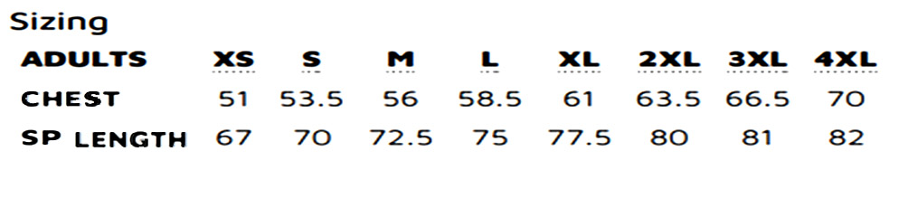
SHIRT SIZING:

